**Test Cases and Scenarios**

|  |  |  |  |  |  |  |  |  |
| --- | --- | --- | --- | --- | --- | --- | --- | --- |
| **ID** | **Test Scenario** | **Test Case ID** | **Test Case Title** | **Test Case Description** | **Steps Followed** | **Expected Result** | **Actual Result** | **Status** |
| **TS001** | A user opens the Website Homepage | FTC001 | Homepage Loading Time | We need to verify that the homepage loading does take longer than 3 seconds to ensure smooth user experience. | 1. Visit xenonstack.com  2. Wait for the website to load completely. | The website should load in the given timeframe. | The website takes too long to load completely | Fail |
| FTC002 | Homepage Loading | We need to verify if on loading the title of the page is correctly loaded and all sections in the page are also loaded properly. | 1. Visit xenonstack.com  2. Verify the page title contains “**Data Foundary for Agentic Systems**”.  3. Check if all sections load properly. | The website should load properly with all sections and CSS displayed properly. | The website loads properly with the correct title and all sections loaded. | Pass |
| **TS002** | The user wants to open the Navbar Links | FTC003 | Navbar Links | We need to verify all the navbar links work properly | 1. Visit xenonstack.com  2. Click on the Navbar Menu items one by one and see if the required change occurs. | The Website should scroll down to the section pointed by the navbar item. | The Website does not scroll down and remains static and clicking on the navbar items does not affect the website state. | Fail |
| **TS003** | The user wants to Fill the Get Started Form | FTC004 | Empty Form Validation | We need to verify that if the Get Started Form is left empty, an appropriate error message appears. | 1. Visit xenonstack.com  2. Click on the ‘**Get Started**’ button.  3. Scroll down and click on ‘**Proceed Next**’.  4. Verify error message. | The Website should prompt an error message when clicked on ‘Proceed Next’ | The Website correctly prompts an error message on Empty Form Submission | Pass |
| FTC005 | Form Input Validation | We need to verify the input type for Form Fields in the Get Started Form. | 1. Visit xenonstack.com  2. Click on the ‘**Get Started**’ button.  3. Enter Special Characters into the Name field.  4. Verify error message  5. Enter Numbers into the Name field.  6. Verify error message.  7. Enter an invalid email into email field.  8. Verify error message.  9. Enter an invalid contact number  10. Verify error message  11. Select any industry from dropdown.  12. Verify its selection.  13. Select Others (Please Specify) from the dropdown.  14. See if the Text Box appears for entering the industry.  15. Verify the result. | The Website should respond with proper error messages when invalid data is entered into the form | The Website correctly provides error messages for all the form fields but does show the Other’s text box when selecting the option. | Fail |
| FTC006 | Successful Form Submission | We need to verify if entered the data correctly is the request submitted. | 1. Visit xenonstack.com  2. Click on the Get Started Button.  3. Enter all the data correctly and then Submit the form. | The Website should properly gather all the data and submit it after successful form completion. | The Website successfully submits the form. | Pass |
| **TS004** | The user wants to open the website on a mobile device. | FTC007 | Mobile Responsiveness | We need to verify the website works on mobile and the navbar gets optimized according to the window size. | 1. Visit xenonstack.com  2. Resize the browser to mobile dimensions.  3. Click the menu icon  4. Verify that the menu opens correctly.  5. Click on the close button to close the menu.  6. Verify that the menu is closed. | The Website should properly open in the Mobile window and the Menu button should work fine with the correct list showing up when clicked. | The Website works properly in mobile dimensions. | Pass |
| **TS005** | The user wants to open the links in the footer | FTC008 | Footer Links | We need to verify that all the footer list items have links present and all of them are working | 1. Visit xenonstack.com  2. Extract all the footer links.  3. Get response times on the links to verify their working. | Every element in the website footer a tag should have a href link and it should be easily opened. | There are many elements with missing links in the footer element. | Fail |
| **TS006** | The user wants to open the external links in the body of the website. | FTC009 | Body External Links | We need to verify that all the external links in the body are accessible. | 1. Visit xenonstack.com  2. Get all the external body links.  3. Get the request response for all the links to validate them. | Every link should work properly in the body of the website. | All the body links are accessible easily. | Pass |
| **TS007** | A malicious user wants to access the website and perform injection | FTC010 | SQL Injection | We need to verify that the forms do not pass the injection statements to the database. | 1. Visit xenonstack.com  2. Click on the ‘**Get Started**’ button.  3. Enter the statement (1 OR 1=1) into one of the fields along with other data and then click ‘**Proceed Next**’.  4. Verify the error message. | The website should not allow the form to be submitted. | The form is not submitted, and error is shown when clicked Proceed Next. | Pass |
| FTC011 | XSS Injection | We need to verify that the form on the website can avoid an XSS attack. | 1. Visit xenonstack.com  2. Click on the ‘**Get Started**’ button.  3. Enter the statement <script>alert(‘XSS’)</script> into one of the fields along with other data and then click ‘**Proceed Next**’.  4. Verify the error message. | The website should not allow the form to be submitted. | The form is not submitted, and error is shown when clicked Proceed Next. | Pass |
| **TS008** | The company’s website is under heavy load daily | NFTC012 | Load testing | We need to verify the company’s website server can handle a large number of users together for some duration of time. | Nil | The website should be able to handle the load for an extended period of time and respond properly. | Only 29% of the requests return a status 200 (OK) | Fail |
| **TS009** | The company’s website has a sudden spike of users. | NFTC013 | Spike Testing | We need to verify that the company’s website server can handle a sudden increase in the number of users and serve every user properly | Nil | The website should be able to handle the spike in users. | Not a single request was completed | Fail |
| **TS010** | The company’s website is stress tested to see the limits of its user handling capacity. | NFTC014 | Stress Testing | Stress testing helps to understand the upper limits of capacity within the system. It identifies the breaking points of an application. | Nil | The website should be able to handle most of the requests provided. | Not a single request was completed. | Fail |

**Bug Report**

|  |  |  |  |  |  |  |  |  |
| --- | --- | --- | --- | --- | --- | --- | --- | --- |
| **Bug ID** | **Test Case ID** | **Bug Description** | **Steps to reproduce** | **Expected Result** | **Actual Result** | **Severity** | **Environment** | **Attachment** |
| BG001 | FTC001 | When opening the website, the load time is too long. | 1. Visit xenonstack.com | The website should respond and open within 3 seconds. | The website takes too long to open. | Medium | Linux-6.8.0-52-generic-x86_64-with-glibc2.35 | {LOG} |
| BG002 | FTC003 | On clicking on the navbar items, the website does not respond and scroll to the section or move to external page. | 1. Visit xenonstack.com  2. Click on the items in the navbar.  3. Now observe if the page scrolls down or moves to a new URL or not, | The Page should scroll to the respective sections or open new external pages on clicking the navbar links | The page does not do anything and clicking the links has no effect. | Medium | Linux-6.8.0-52-generic-x86_64-with-glibc2.35 | {LOG} |
| BG003 | FTC005 | When filling in the **Get Started form**, when the user selects **Other (Please Specify)** in the Industry Dropdown, a new text box should appear to enter the industry, but no new text box is added. | 1. Visit xenonstack.com  2. Click on the **Get Started** button.  3. Fill in the user details in the correct format.  4. In the industry dropdown, select the **Others (Please Specify)** option.  5. Now observe if a text box appears or not. | There should be a text box generated once the others option is selected | No text box is created after selecting the others option. | Medium | Linux-6.8.0-52-generic-x86_64-with-glibc2.35 | {LOG} |
| BG004 | FTC008 | When clicking at some of the links in the footer, they do not have an href element and thus reload the page URL itself. | 1. Visit xenonstack.com  2. Go to the footer section of the home page.  3. Click on the elements present there.  4. Observe how not all of them have an embedded link and some just reload the page. | There should be an external link or a product page link to all of the elements in the footer. | Some of the elements in the footer do not have any link. | High | Linux-6.8.0-52-generic-x86_64-with-glibc2.35 | {LOG} |
| BG005 | NFTC012 | When a large number of users are accessing the website together, then there are a lot of failed requests. | Nil | All the user requests should be passed and should have a status of 200 (OK). | Only 29% of the requests got a status of 200 (OK). | High | Linux-6.8.0-52-generic-x86_64-with-glibc2.35 | {LOG} |
| BG006 | NFTC013 | When altogether there is a sudden spike in users on the website, there are a lot of failed requests. | Nil | All the user requests should be passed and should have a status of 200 (OK) | No user request got the status of 200 (OK) | High | Linux-6.8.0-52-generic-x86_64-with-glibc2.35 | {LOG} |
| BG007 | NFTC014 | On stress testing the website, there are no request accepted on the URL. | Nil | Most of the user requests should be passed and should have a status of 200 (OK) | No user request got the status of 200 (OK) | High | Linux-6.8.0-52-generic-x86_64-with-glibc2.35 | {LOG} |

## BG001

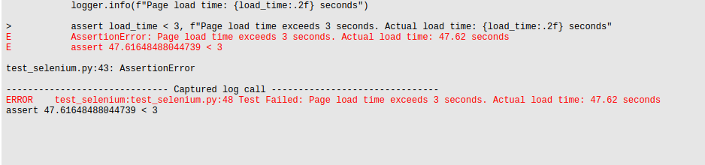

## BG002

## 

## BG003

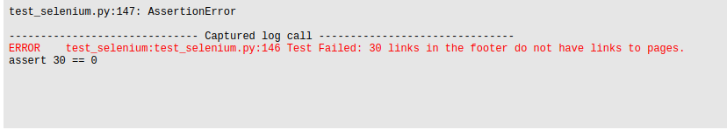

## BG004

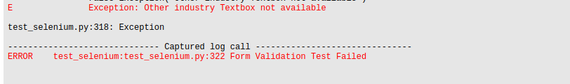

## BG005

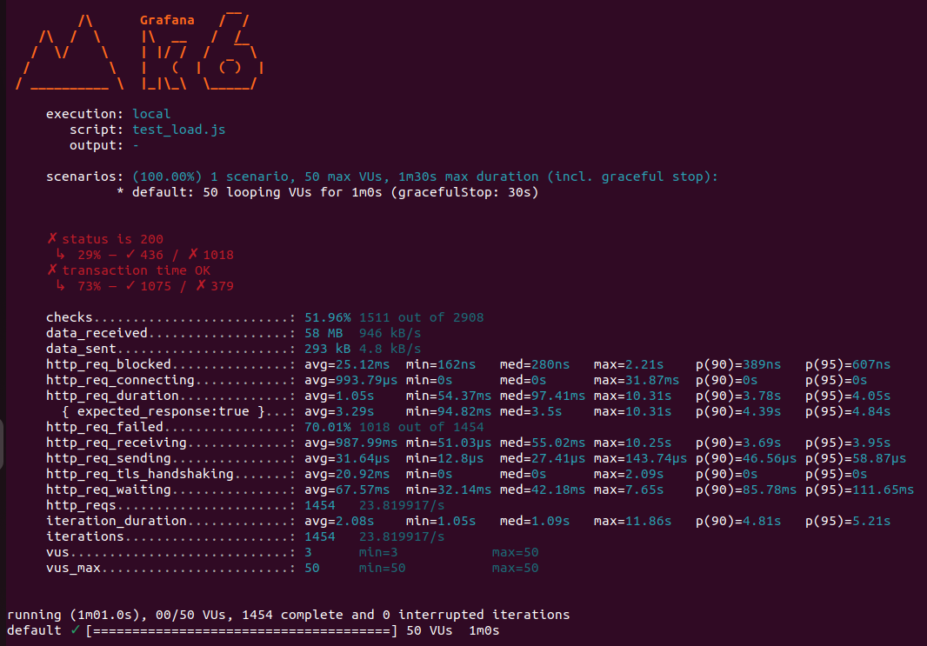

## BG006

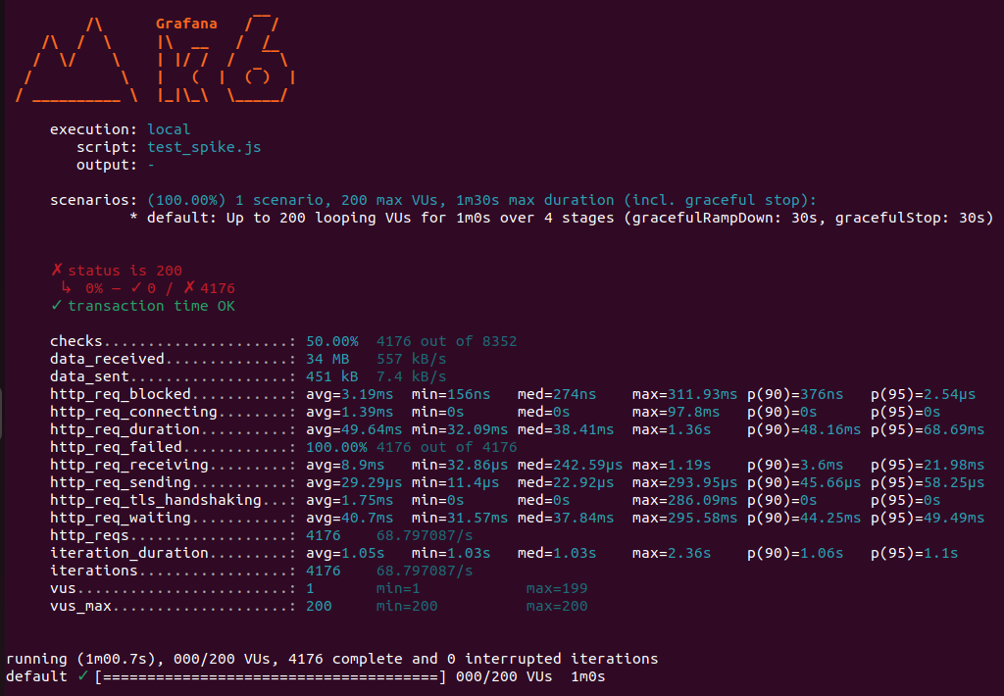

## BG007

